INFOLABZ IT SERVICES PVT LTD

REACT | ASSIGNMENT 5 | 01 MARCH 2024

1. **Create object as following format :**

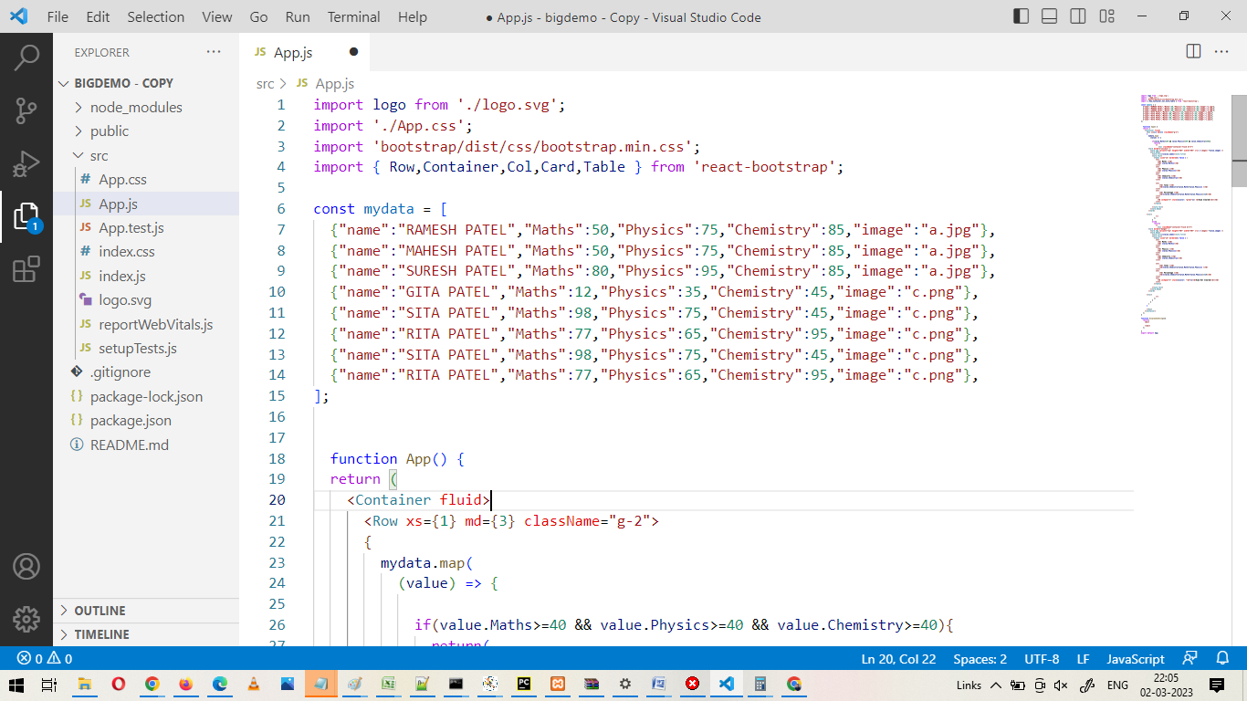

Crate images folder and add images. Prepare a React bootstrap card with images, marks etc

Reference : <https://react-bootstrap.netlify.app/docs/components/cards/>

Print above data using map as shown in below video output.

[React App.mp4](https://drive.google.com/file/d/1Ikf6zKZ0Teoyfl-ysWzcM-cCLF4ko9WS/view?pli=1)

**Conditions :**

1. It should be conditional mapping. Total and Percentage field should be calculated from above data.
2. If marks of any subject is in less than 35 print **exam not cleared** in red font otherwise print **exam cleared** in green font.
3. If the exam is cleared then the card should be in green bordered color otherwise red bordered color.

**2) Copy and paste data from university API and print data using map in react bootstrap** bordered table with hover effect.

API : <http://universities.hipolabs.com/search?country=india>

SR NO | University Name | Webpage

**3) REACT HOOKS ( FUTURE POW) :**

Load real time bitcoin data from below API. Data should e changed automatically in every 10 seconds. If bitcoin rate gets changed, it should be reflected at user side without any kind of reload.

Link : <https://api.coindesk.com/v1/bpi/currentprice.json>